GOOD SHEPHERD

COLLECTION

For the Retired Diocesan Priests

April 20 & 21, 2024

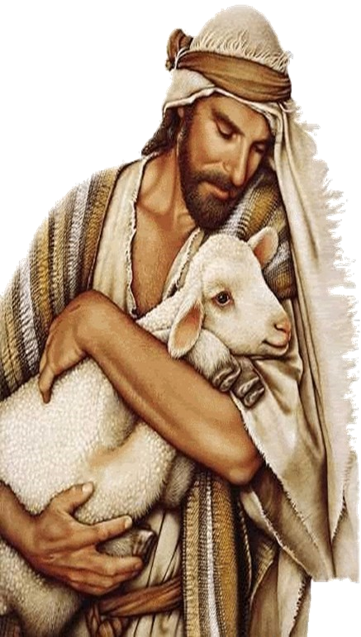

The Diocese of Erie is committed to caring

for our retired priests. Our annual

collection provides additional financial

resources to support the retired priests,

and those who now serving in our Diocese.

Thank you for your generous support in

past years. Please remember in your

prayers all of our priests.

Prayer for our Retired Priests

We pray for the retired priests of our Diocese that they may experience

peace and joy in their retirement and in thanksgiving for the countless

years of service they have provided and continue to provide to people of God in the Diocese of Erie.

\*

For direct contributions, please make payable to the Diocese of Erie

Monsignor Magraw at St. Mark Catholic Center P.O. Box 10397 Erie, PA 16514-0397