GOOD SHEPHERD COLLECTION DATES

Good Shepherd Sunday – Fourth Sunday of Easter – Also World Day of Prayer for Vocations. The date for the Annual Collection for our retired diocesan priests will vary each year from mid-April to mid-May. Good Shepherd Sunday is three weeks after Easter. When your envelope company sends the listing for the approved Second Collections for the Diocese of Erie please have your staff check the date and make changes to your parish listing.

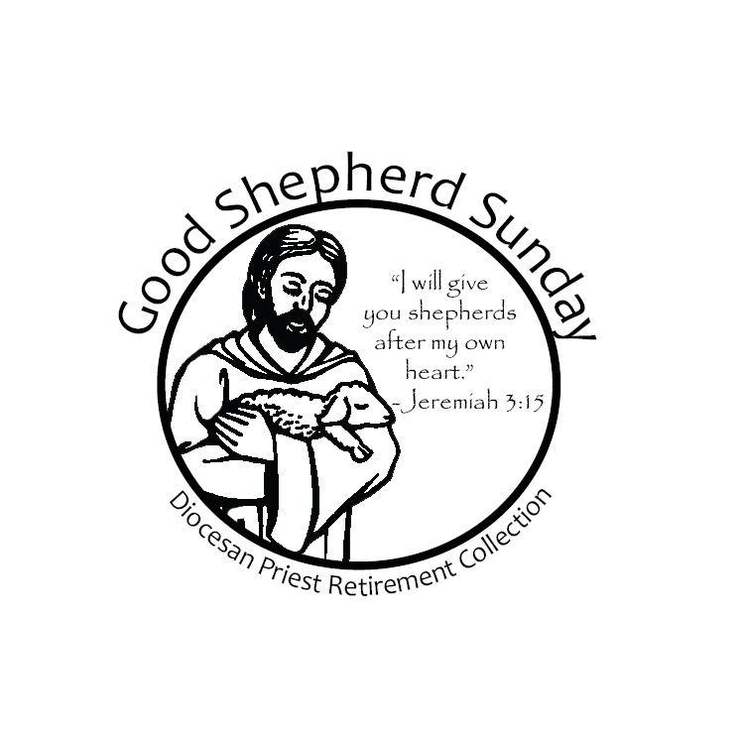

UPCOMING
COLLECTIONS:

2025 – May 11
2026 – April 26
2027 – April 18
2028 – May 7
2029 – April 22

Check your list for the
Envelope Company

