GOOD SHEPHERD CLIP ART
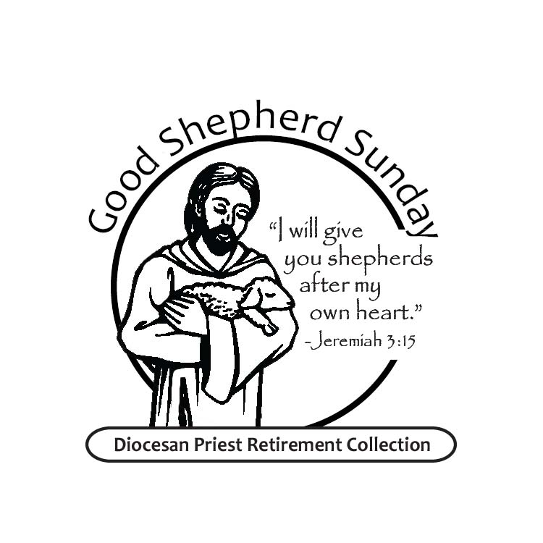

GOOD SHEPHERD COLLECTION
DIOCESAN PRIEST RETIREMENT
April 20 & 21, 2024

ERIE DIOCESAN PRIEST RETIREMENT
GOOD SHEPHERD COLLECTION

Provides for our priests
the same love and generosity
they have provided us
for generations

April 20 & 21, 2024

Do you remember the Parish Priest
who heard your First Confession
gave you First Holy Communion
helped you prepare for Confirmation
was there again when you said: I do,”
visited you or a loved one
while hospitalized, encouraged you in time of need?
Our priests have been actively involved in so many ways
in our spiritual life even after they retire.

As the priest shortage increases,
the number of retired priests will increase
but not nearly as fast as their health care needs
and other soaring retirement expenses.

Good Shepherd Sunday
is your opportunity to say thanks
to our retired Erie diocesan priests
for their many years of faithful service.
Provide for them the same love, care and generosity
they have provided for us for generations.

