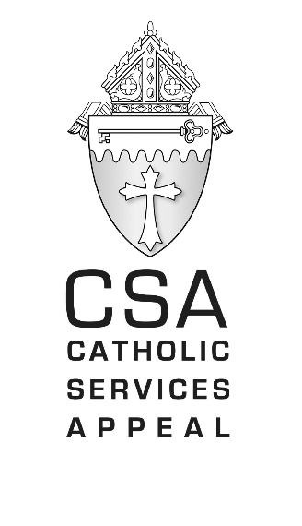

Sample Bulletin / Pulpit Messages

February 4/5 Announcement Weekend (2 weeks prior to Commitment Sunday)

The 2023 Catholic Services Appeal will be conducted throughout our diocese on February 19. The CSA is the main source of support for projects and services of the diocese which serve parishes and the wider community in northwestern Pennsylvania. Our diocese does the work of the Gospel and needs your help to continue this important work.

Bishop Lawrence Persico assures us that funds donated to the CSA are placed in a designated account and used solely to support the programs and ministries of the diocese and cannot be used for any other purpose.

The CSA is essential to helping the Diocese of Erie fulfill its mission to evangelize, educate, serve, proclaim the Word, celebrate the sacraments, and provide hope to people in need. Your participation ensures the success of the CSA and is important to the health of our parish. Please join other Catholics from across the 13 counties of our diocese in supporting this important appeal.

February 11/12 Promotion Weekend (1 week prior to Commitment Sunday)

The 2023 Catholic Services Appeal will be held next weekend in our parish. The CSA is an opportunity for Catholics throughout the diocese to join together in doing the work of the Gospel. The CSA reminds us that we are all part of the same Catholic family and that the work of the diocese is the work of the church. The church serves each of us and our support is essential in continuing God’s work in our area. Every CSA donation also brings us closer to being able to complete our own parish project [describe parish project]. No gift is too small, but please give as generously as you can.

February 18/19 Commitment Sunday

Today is Commitment Sunday for the 2023 CSA. Only by working together can we make it possible for parishes, Catholic schools, Catholic Charities, clergy and the Catholic faithful to live and share Christ’s teaching.

You may wonder why you should support the CSA. The truth is, as members of the Diocese of Erie, we play an important role in the diocesan activities of Catholic education, evangelization, promoting justice and serving people in need throughout our diocese. Our diocese has work to do on behalf of the Lord and we are all asked to share our gifts to help advance the mission of the church.

Our bishop assures us that donations to the CSA are placed in a designated account and used solely to support the programs and ministries of the diocese and cannot be used for any other purpose

Your gift is so important. Thank you for giving.

February 25/26 (the week following Commitment Sunday)

A sincere thank you to all who made a pledge and/or gift to the Catholic Services Appeal. You have joined together with Catholics throughout the Diocese of Erie to share of your blessings to help advance the mission of the church. I am grateful.

If you have not yet made a commitment, it is not too late. Just drop your pledge card or envelope marked ‘CSA’ in the collection basket or turn it in at the parish office. Your generosity is appreciated.

Pulpit remarks given on Promotion Sunday (1 week prior to Commitment Sunday).

Every year the diocese runs the Catholic Services Appeal. Do you wonder what this appeal actually funds? Referring to the February issue of Faith magazine, we see that each year, the bishop asks the faithful throughout the Diocese of Erie to support the Catholic Services Appeal (CSA), which is the annual fundraising campaign of the diocese. The CSA funds programs and ministries that are beyond the resources of any one parish. Every diocesan office and ministry supported by the CSA, such as the Catholic Schools Office, Office of Faith Formation, Catholic Charities, and Office of Communications, are available to assist in every area of the diocese. The CSA reminds us that we are all part of the same Catholic family and that the work of the diocese is the work of the church. By joining together, we can accomplish more than any one parish can accomplish on its own.

Next week we will ask each of you to complete a CSA pledge envelope during Mass. [or soon you will be receiving a letter and pledge envelope in the mail asking for your support]. Please prayerfully consider making a gift to support the CSA.

Pulpit remarks given on Commitment Sunday

The Catholic Services Appeal is the annual fundraising campaign of the Diocese of Erie. It is important because it calls us to join together with Catholics from throughout the diocese to do the work of the Gospel - to evangelize, educate, serve, proclaim the Word, celebrate the sacraments and give hope to people in need.

Gifts to the CSA are put to work immediately to support the ministries and day-to-day programs of the Catholic Church in our diocese and are not invested or reserved for future use.

Our Catholic Services Appeal reminds us that we are all part of the same Catholic family and that the work of the diocese is the work of the church. Despite the challenges we face as a Catholic Church, there are still hungry people who need to be fed. There are still homeless who need shelter, and there are still people who need to be formed in the faith. I ask for your support to help us do the work of the Gospel with a donation to the CSA. Please give.

Your participation is essential to the success of the CSA as well as to the health of our parish. Thank you for joining other Catholics from across the 13 counties of our diocese in supporting this important appeal.

