Religious Education Leadership

Diocesan Professional Agreement

Table of Contents

General Introduction and Code of Ethics |  | Page 2
Pastor’s Checklist for completing process |  | Page 3
Part A – Agreement Rationale |  | Page 4
Professional Agreement – Part A |  | Pages 5-6
Part B -Salary and Benefit Calculation Rationale |  | Pages 7-10
Professional Agreement – Part B |  | Page 11-12
Part C - REL Titles & Qualifications Rationale |  | Pages 13 - 14
Job Description: Director |  | Pages 15-17
Job Description: Coordinator |  | Pages 18-20
Job Description: Administrator |  | Pages 21-23

Religious Education Leadership

Professional Agreements

General Introduction

The essence of any ministry is defined by the quality of the relationship that is established between two people. Said in another way; if in relationships, people act contray to the Gospel, then our preaching and teaching become nothing more than "a noisy gong or a clanging cymbal."

This is as true for an employer/employee relationship as it is for visiting the hospital or counseling someone. Whenever any two people enter into a relationship it is to be expected that there will be both disagreement and conflict. In the majority of cases these disagreements are handled through conversation and negotiation. When a serious conflict arises concerning the performance of job requirements or negligence of duty however, the conversation needs to be guided by carefully crafted documents that articulate commonly agreed upon expectations.

The purpose of a Professional Agreement between a Pastor and a Religious Education Leader is to define expectations and to make them both clear and explicit. A process for establishing a Professional Agreement is presented on the following pages..

The Diocese of Erie has chosen to use the term "Professional Agreement" instead of contract for two reasons. The first reason is to recognize and define that the relationship between a parish and a religious education leader is to be recognized as a professional relationship. This makes the religious education leader an "exempt" employee of the parish subject to the rights and responsibilites so implied.

The second reason for the use of the term "Professional Agreement" is to by-pass language that is clearly legal in the civil sense in favor of language that is binding within Church law. It is intended that all conflicts between parishes and religious education personnel be resolved within established canonical processes.

Code of Ethics
Religious education leaders must recognize that they represent a religious organization and that this makes certain demands on their conduct. The parish has the right to dismiss the religious education leader for issues such as serious public immorality or public scandal. The religious education leader, as a public representative of the Church, has the obligation to authentically teach Church doctrine. The parish has the right to dismiss the religious education leader for publically and knowingly teaching doctrine that is contrary to the official teaching of the Roman Catholic community. These rights, held by the parish, are subject to those rights afforded to members of the Catholic community for the vindication of rights in the Code of Canon Law and/or the Diocese of Erie.

Religious Education Leadership - Diocese of Erie

Diocesan Professional Agreement

Pastor’s Checklist & Process Sheet

Part A - Agreement Date for Your Records
Page 1 of Agreement completed:
Page 2 of Agreement completed:
Religious education leader reports to completed:
Date for annual review is scheduled:

Part B – Salary and Benefits
Salary calculated (see pages 7-10 for help
in establishing salary) and recorded on Page 2 of “Part A – Agreement” and “Part B-Salary & Benefits” :
Benefits agreed upon:

Part C 1 - Titles and Qualifications
For the purpose of this agreement, based on Diocesan definitions, the pastor has chosen to use the title noted on the right by a check:  (for help in determining the correct title please see pages 13-14) |  | Director of Religious Education
 |  | Coordinator of Religious Education
 |  | Administrator of Religious Education
 |  | Facilitator of Religious Education

Part C 2 - Job Description – Delete Items
Items from the job description noted above have been reviewed and any items that do not apply have been removed: |  | Yes, the job description is amended.

Part C 3- Job Description: Specific Additional Responsibilites
Items from the job description noted above have been reviewed and items have been added as required. |  | Yes, the job description is amended.

To print a complete copy of the agreement please print: Pages – 5-6,11 and the three pages of the amended job description that you chose.

Religious Education Leadership

Diocesan Professional Agreement
Part A - Agreement

Relationship with the Parish: | It shall be the responsibility of the religious education leader to report directly to the pastor. If the pastor elects to delegate this responsibility to any other person or agency (e.g., a Parochial Vicar or Religious Education Board) it should be noted in Part A - Reporting.
Evaluation: | The pastor, or his assigned delegate, will conduct a review of the religious education program and the performance of the religious education leader. A 6-month review is recommended and a yearly review is good personnel practice. The religious education leader will render to the parish a written report of the activities of the current year, with an evaluation, and proposals for the following year. The pastor or delegate shall evaluate this report, conduct a review of the activities, program and performance of the religious education leader and decide whether or not to renew the employment of the religious education leader. On or before May 1, the parish will notify the religious education leader whether his/her employment will be renewed.
Resolution of Disputes: | In the event of a concern regarding conduct or job performance of the religious education leader, the pastor or his delegate must use the Diocese of Erie policy concerning the Resolution of Disputes. Contact the Diocesan Judicial Vicar for information concerning this process.

Religious Education Leadership

Diocesan Professional Agreement

Part A

This professional agreement, made and entered into this day of , 20 ,
by and between ,( Employer), and party of the second part, hereinafter referred to as Religious Education Leader (REL).

WITNESSETH, that the parties hereto, in consideration of the mutual promises and covenants hereinafter contained and intending to be bound thereby, agree as follows:

1. REL agrees to serve the aforesaid Parish for a term commencing and ending .

2. Parish is the sole and exclusive Employer of the REL for purposes of this Professional Agreement and any rights and duties created herein. All references to the Diocese of Erie are as a religious body only, and not as Employer of the REL.

3. The REL agrees to perform the duties set forth in this Professional Agreement for the supervision and administration of a Catechetical Program in Parish for the term of this professional agreement. The REL agrees to perform his/her duties as set forth in Job Description Supplements which are attached hereto and made a part hereof.

4. The REL agrees to perform such duties for the entire professional agreement term, and to be available for meetings and other consultations with the parish administration, parents or pupils as required in the contract supplements.

5. The REL agrees that should he or she work only a fraction of the professional agreement term, the total salary due REL under this agreement shall be a proration of the REL's total gross salary for that portion of service rendered.

6. The REL recognizes the religious nature of the parish's religious education program and agrees that the Employer has the right to dismiss the REL for serious public immorality, public scandal, or public rejection of the official teachings, doctrine or laws of the Roman Catholic Church, thereby terminating any and all rights that the REL may have hereunder, subject, however, to the REL's right to access grievance procedures and other procedures for vindicating rights promulgated by the Code of Canon Law and/or the Diocese of Erie.

Diocesan Professional Agreement

Part A, cont'd
7. Employer reserves the right to terminate the REL for cause during the term of this professional agreement. Cause shall include, by way of example and without being limited to, incompetency, insubordination, neglect of duty, and failure to perform in accordance with the terms and conditions of employment as specified by Employer. Dismissal for "cause" will be in writing specifying the reason for the dismissal.

8. The REL and the Employer agree that they will provide to each other thirty (30) days written notice prior to the end of the professional agreement whether each wishes to renew this agreement. The purpose of reciprocal notice is for planning purposes. This is a professional agreement for a specified term and is not automatically renewable.

9. Employer agrees to pay the REL for the performance of his or her duties the total gross salary of $ , payable in equal monthly installments beginning the
day of . From this gross amount such deductions as are required by law will be made. These dates are for purposes of payment only. The professional agreement term shall be as described in paragragh 1 above.

10. Employer agrees during the term of this professional agreement to provide for the REL those benefits mutually agreed upon in Supplement attached, explaining such programs and in accordance with the eligibility requirements therein contained.

11. No party of this agreement may bring civil action or seek administrative relief in civil law from the other party for breach of this professional agreement or for any other reason arising out of the employment relationship herein created without first having exhausted all remedies and recourses afforded by ecclesiastical law.

IN WITNESS WHEREOF, the parties hereto have hereunto set their hand and seals the day and year first above written.

______________________________ __________________________________
Religious Education Leader Parish

By __________________________________
Pastor

Part A - Reporting

Religious education leader reports to:
Annual review is scheduled for (date):

Religious Education Leadership

Diocesan Professional Agreement

Part B - Salary Calculation Process Explanation

The intention of the following pages is to offer a process that can be used by pastors and religious education leaders of the Diocese of Erie. The purpose of this process is to provide a common ground for salary and benefit discussions. There is no intention to dictate salaries or benefits.

The process will provide a salary figure based on five (5) areas of consideration. It examines the knowledge base (meaning academic credentials); the experience (both volunteer and paid); the size of the program (in # of families serviced); extra duties that the REL will be asked to perform (programs not usually associated with religious education); and performance incentives.

The page entitled "Criteria for Salary Determination" offers some specific guidelines on some of the issues discussed above but is much less specific on others. The rationale for this approach is a recognition that each parish situation is unique. Therefore, the process attempts to offer guidance where appropriate and to leave other issues more open-ended where that is more appropriate.

The "Salary Calculation Form" is provided for convenience and simply provides the user with a place to make salary calculations using the enclosed process.

Base Salary Explained:
Base salary is to be understood to encompass the following:
A. A Bachelor’s degree in Religious Education
b. A moderate to large parish
c. Full time - 12 month employment

Religious Education Leadership

“Criteria” For Salary Determination
1. Knowledge
a. Second Master's in Religious Education 140%
b. Master's in Religious Education +21 credits 135%
c. Master's in Religious Education +9 credits 130%
d. Master's in Religious Education 125%
e. Master's in Theology/Rel. Studies/Pastoral Studies/Education 120%
f. B.A./B.S. & 21 graduate credits in religious education 115%
g. Master's in another field 110%
h. B.A./B.S. & 9 graduate credits in religious education 105%
i. B.A./B.S. with religious education concentration -----
j. Assoc. degree with rel. ed. concentration or BA in Education 95%
k. B.A./B.S. with no religious education credits 90%
l. Religious Education Advanced Certificate 85%
m. No formal higher educational training 80%

2. Experience
a. Part-time/volunteer experience + 1/2% per yr.
b. Full time experience + 01% per yr.

3. Parish Size
a. 1500-2000 families 106%
b. 1000-1500 families 103%
c. 500- 999 families ------
d. 300- 499 families 97%
e. 100- 299 families 94%
f. less than 100 families 90%

4. Additional Areas of Responsibility
Examples:
a. R.C.I.A. +02%
b. Sunday Liturgy of the Word for Children +02%
c. Parish Census +02%
d. Small Christian Communities +02% These extra duties are determined by evaluating whether they are part
of the original Professional Agreement or not.

5. Performance
Determined as a percentage of the salary and derived from accomplishment of stated program objectives. (Not used for a new employee)

6. Employment Status
100% = Full Time
83% = 10 Months Full Time
50% = Part Time (These figures are recommended, not mandated)
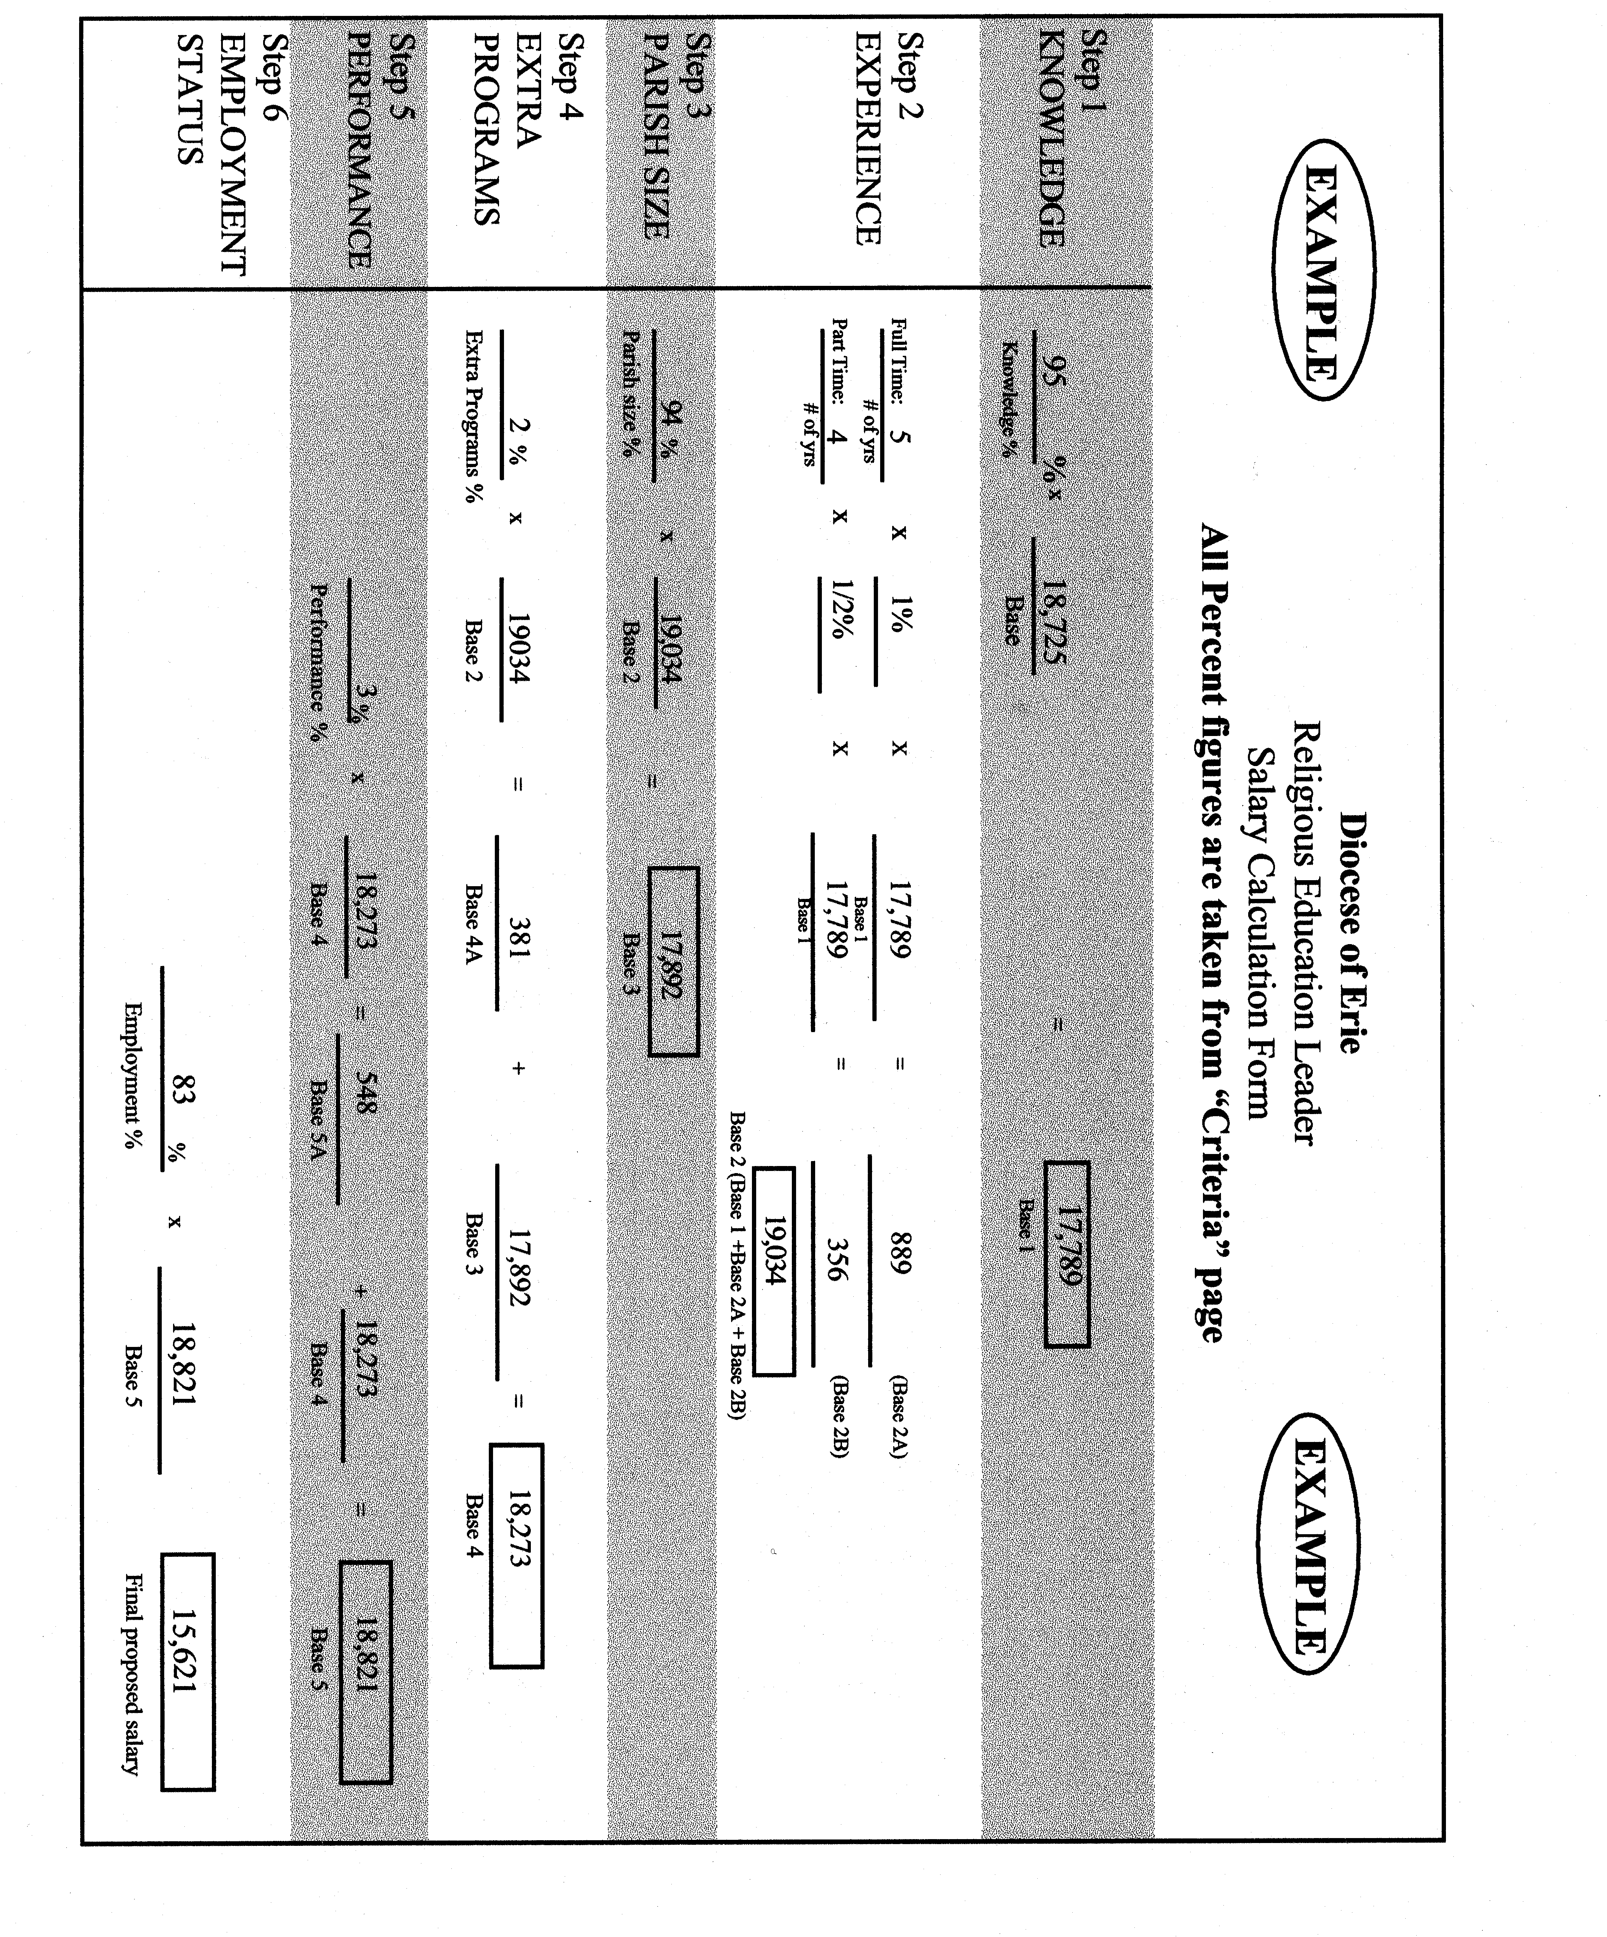

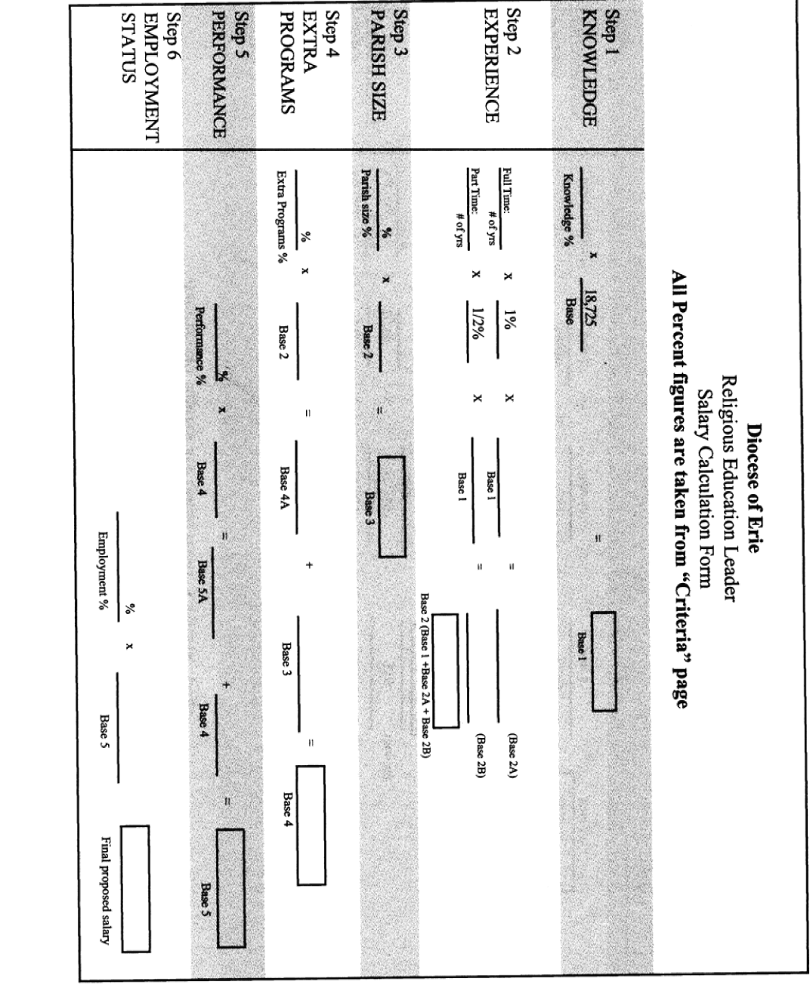

Part B - Salary and Benefits Salary:  The employer is to pay an agreed-upon base salary per year, payable in equal amounts. Salary is subject to federal withholding and social security taxes. |  | $
I. Health and Retirement Benefits
In addition, the employer and employee agree to benefits designated as follows (if a benefit is not to be paid please enter 0.00 on the line).
Diocesan Personnel Code
(501) | Retirement/Pension Plan | $
(503) | Health/Medical | $
(505) | Social Security Benefits | $
(506) | Workers Compensation | $
 |  | Sub-Total: $
II. Other Employee Benefits:
 | Housing | $
 | Automobile/Travel  (.50 per mile) | $
 | Continuing Education | $
 | Professional Memberships | $
 |  | Sub-Total: $
 | Total Wage & Benefits | $

A full time Religious Education Leader is entitled to the same schedule of paid holidays as observed by the Diocese. In addition, the employer and employee agree to the following Holiday/Leave Benefits.
Diocesan Personnel Code |  | Diocesan | Agreed Upon
(405) | Paid sick days | 6
(406/407 | Paid Vacation Days | 1 yr. - 10 days  5 yr. – 15 days  10 yr. – 20 days  20 yr. – 25 days
(409) | Personal Days | 2
(411) | Days for Serious Family Illness | 5 days
(412/413) | Maternity/Paternity leave (unpaid) | 3 mos
(406-G) | Retreat Days Paid | 3

Part B - Benefits Explained

Participation in workshops, job related meetings, ongoing educational and professional organizations will be considered part of the time which is compensated. This time, however, must be a reasonable percentage of work time.

Diocesan Paid Holidays (typically):

New Year's Day
Martin Luther King
Good Friday
Easter Monday
Memorial Day
Independence Day
Labor Day
Thanksgiving Day
Day after Thanksgiving Day
Day before Christmas
Christmas Day
Day before New Year's Day

Religious Education Leadership

Diocesan Professional Agreement

Part C - Titles and Qualifications – Introductary Notes

The Diocese has chosen to accept the definitions of the National Conference of Catechetical Leadership in recognizing three levels of Religious Education Leadership. The fourth level, Facilitator of Religious Education, is considered an entry level position only. A person being hired at this level is expected to pursue further certification as noted.

1. Director of Religious Education

To be considered a Director one must have a master's degree in religious education, education, religious studies or its equivalent. It would be expected that persons with degrees in education would have 18 credits of theology/religious studies and those with master's in theology/religious studies would have 12 credits in religious education or education. Persons with a masters degree in a field other than religious education, education, or theology/religious studies would be expected to have a graduate certificate in religious education.
• A professional agreement is a Diocesan requirement for Directors of Religious Education.

2. Coordinator of Religious Education

To be considered a Coordinator one must have a bachelor's degree in religious education.
or
Persons having a bachelor's degree in religious studies will be considered a Coordinator with the completion of 12 credits in religious education/education.
or
One may also be considered a Coordinator by having a bachelor's degree in a field other than religious education and by having completed a recognized "Advanced Certificate Program" (minimum 21 credits).
or
One may be considered a Coordinator by completing an "Advanced Certificate Program"(minimum 21 credits) and successfully leading a religious education program for 5 years.
• A professional agreement is a Diocesan requirement for Coordinators of Religious Education.

Religious Education Leadership

Diocesan Professional Agreement

Part C - Titles and Qualifications – Introductary Notes

3. Administrator of Religious Education

To be considered an Administrator one must have completed a recognized "Advanced Certificate Program" in religious education (minimum of 21 credits).
• A professional agreement is suggested but not required for Administrators of Religious Education

4. Facilitator of Religious Education

Anyone working as a Religious Education Leader in the Diocese who has not achieved the above credentials will be considered a Facilitator. Every new Facilitator is expected to be enrolled in an "Advanced Certificate" program within two years of their starting date. These expectations shall be a condition for anyone being hired. Facilitators will use the same job description as the Administrator.
• A professional agreement is suggested but not required for Facilitators of Religious Education

Religious Education Leadership

Diocesan Professional Agreement

Part C - Job Description

Director of Religious Education
...catechetical ministry must be understood in relation to Jesus' threefold mission. It is a form of the ministry of the word, which proclaims and teaches. It leads to and flows from the ministry of worship, which sanctifies through prayer and sacrament. It supports the ministry of service, which is linked to efforts to achieve social justice and has traditionally been expressed in spiritual and corporal works of mercy.

NCD, #32

Message
Makes accessible the tradition and heritage of the Church.

Enables "critical thinking skills" so that the Church of today will be prepared for tomorrow.

Initiates, organizes, and evaluates religious education programs that respond to the needs of all parishioners across the life-span in concert with sound educational and research principles and the teachings of the Church.

Is responsible for the appropriate use of texts, audiovisuals etc. in catechetical programs so that all resources meet standards set by sound educational practices and the Diocesan Office of Religious Education.

Enables the writing and ongoing revision of a parish catechetical mission statement and the goals and objectives that respond to that mission which is always a response to God's love and grace.

Prepares and proposes a budget for parish catechetical programs. Responsible for appropriate accountability procedures.

Community
Enables the religious education staff to provide an atmosphere of mutual support and the sharing of life and faith.

Enables the religious education staff and students to see themselves as evangelizers to one another and the world.

Actively promotes the idea that faith is not a private reality but a community gift and that it must be shared if it is to grow and have life.
Diocesan Professional Agreement
Part C - Job Description
Director of Religious Education

Administration
Recruits, trains (provides access to Diocesan training), and supports volunteer catechists for those areas of the catechetical program where volunteerism is appropriate.

Calls and ordinarily presides over regular and special meetings of the staff of the parish Religious Education program as required.

Recruits other professional support for programs where expertise is required.

Supervises and evaluates the operation of the programs, personnel, activities and facilities.

Supervises the keeping of records, the work of the Religious Education office, and sends periodic reports to the pastor, appropriate committees, and Diocesan Office.

Meets regularly with the Pastor and/or his delegates (the parish team where it exists) to discuss with and inform them of matters concerning the catechetical program.

Is an advisor to the Education Commitee of the Pastoral Council or other appropriate parish structure.

In parishes with a parochial school the DRE works collaboratively with the principal in supporting appropriate catechetical service.

Serves as liaison between the parish and diocesan personnel in the area of parish catechesis as covered by the Professional Agreement.

Is a person with good communication skills who is responsible for promoting good public relations with other parish organizations, the local community, especially the public school, in matters pertaining to Religious Education.

Diocesan Professional Agreement
Part C - Job Description
Director of Religious Education

Worship

Leads the staff of the religious education program in the development of appropriate prayer for all students of catechetical age.

Leads the staff of the religious education program in the development of a prayer life appropriate to support and sustain the parish catechetical effort.

Leads all children/youth of catechetical age to an appreciation of the Eucharist as the center of Catholic life.

Enables staff and students in the celebration of the great feasts of the Church's liturgical year.

Leads (or trains appropriate leadership for) parent meetings for sacraments appropriate to the parish structures and Diocesan guidelines in concert with sound theological and educational principals.

Service

Leads the staff of the religious education program in the development of appropriate service opportunities for all students of catechetical age attentive to developmental issues.

Works with adults of the parish to keep the parish informed of international, national, and local issues related to Christian service.

Supports the development of a sound understanding of Catholic Social Teaching which includes issues of both charity and justice

Religious Education Leadership

Diocesan Professional Agreement

Part C - Job Description

Coordinator of Religious Education

...catechetical ministry must be understood in relation to Jesus' threefold mission. It is a form of the ministry of the word, which proclaims and teaches. It leads to and flows from the ministry of worship, which sanctifies through prayer and sacrament. It supports the ministry of service, which is linked to efforts to achieve social justice and has traditionally been expressed in spiritual and corporal works of mercy. NCD, #32

Message

Makes accessible the tradition and heritage of the Church.

Enables "critical thinking skills" so that the Church of today will be prepared for tomorrow.

Initiates, organizes, and evaluates religious education programs that respond to the needs of all parishioners across the life-span (or for the particular age group for which the coordinator is hired) in concert with sound educational and research principles and the teachings of the Church.

Is responsible for the appropriate use of texts, audio-visuals, etc. in catechetical programs so that all resources meet standards set by sound educational practices and appropriate Diocesan agencies.

Follows the parish catechetical mission statement and sets goals and objectives that respond to that mission which is always a response to God's love and grace.

Prepares and proposes a budget for parish catechetical programs. Responsible for appropriate accountability procedures.

Community

Enables the catechetical staff to provide an atmosphere of mutual support and the sharing of life and faith.

Enables the catechetical staff and students to see themselves as evangelizers to one another and the world.

Actively promotes the idea that faith is not a private reality but a community gift and that it must be shared if it is to grow and have life.
Diocesan Professional Agreement
Part C - Job Description
Coordinator of Religious Education

Administration

Recruits, trains (provides access to Diocesan training) and supports volunteer catechists for those areas of the catechetical program where volunteerism is appropriate. The Coordinator provides resource persons for the training and support of catechists as needed.

Calls regular and special meetings of the staff of the parish Religious Education program as required. The coordinator will preside over meetings when possible and provide other appropriate resource persons when necessary.

Recruits other professional support for programs where expertise is required.

Supervises and evaluates the operation of the programs, personnel, activities and facilities.

Supervises the keeping of records, the work of the Religious Education office, and sends periodic reports to the pastor, appropriate committees, and Diocesan Office.

Meets regularly with the Pastor and/or his delegates (the parish team where it exists) to discuss with and inform them of matters concerning the catechetical program.

Is an advisor to the Education Committee of the Pastoral Council or other appropriate parish structure.

In parishes with a parochial school the CRE works collaboratively with the principal in supporting appropriate catechetical services.

Serves as liason between the parish and diocesan personnel in the area of parish catechesis as covered by the Professional Agreement.

Is a person with good communication skills who is responsible for promoting good public relations with other parish organizations, the local community, especially the public school, in matters pertaining to Religious Education.

Diocesan Professional Agreement
Part C - Job Description
Coordinator of Religious Education

Worship

Leads the staff of the religious education program in the development of appropriate prayer for all students of catechetical age.

Leads the staff of the religious education program in the development of a prayer life appropriate to support and sustain the parish catechetical effort.

Leads all children/youth of catechetical age to an appreciation of the Eucharist as the center of Catholic life.

Enables staff and students in the celebration of the great feasts of the Church's liturgical year.

Arranges parent meetings for sacraments appropriate to the parish structures and Diocesan guidelines in concert with sound theological and educational principles. The coordinator is encouraged to lead parent meetings within the limits of their expertise and to provide other resource persons when appropriate.

Service

Leads the staff of the religious education program in the development of appropriate service opportunities for all students of catechetical age attentive to developmental issues.

Works with adults of the parish to keep the parish informed of international, national, and local issues related to Christian service.

Supports the development of a sound understanding of Catholic Social Teaching for the religious education staff which includes issues of both charity and justice.

Religious Education Leadership

Diocesan Professional Agreement

Part C - Job Description

Administrator of Religious Education
...catechetical ministry must be understood in relation to Jesus' threefold mission. It is a form of the ministry of the word, which proclaims and teaches. It leads to and flows from the ministry of worship, which sanctifies through prayer and sacrament. It supports the ministry of service, which is linked to efforts to achieve social justice and has traditionally been expressed in spiritual and corporal works of mercy." NCD, #32

Message

Makes accessible the tradition and hertiage of the Church.

Promotes education in "critical thinking skills" so that the Church of today will be prepared for tomorrow.

Administers an established religious education program that responds to the needs of all parishioners across the life-span under the supervision of the Pastor or his delegate.

Provides appropriate texts, audio-visuals, etc. for catechetical staff so that all resources meet standards set by the Pastor and the Diocesan Religious Education Office.

Follows the parish catechetical mission statement and the goals and objectives that respond to that mission which is always a response to God's love and grace.

Prepares and proposes a budget for parish catechetical programs. Responsible for appropriate accountability procedures.

Community

Enables the religious education staff to provide an atmosphere of mutual support and the sharing of life and faith.

Enables the religious education staff and students to see themselves as evangelizers to one another and the world.

Actively promotes the idea that faith is not a private reality but a community gift and that it must be shared if it is to grow and have life.
Diocesan Professional Agreement
Part C - Job Description
Administrator of Religious Education

Administration

Recruits and supports (provides access to Diocesan training) volunteer catechists for those areas of the catechetical program where volunteerism is appropriate.

Calls and facilitates regular and special meetings of the staff of the parish Religious Education program as required. The administrator will arrange for appropriate leadership for these meetings as required.

Recruits professional support for programs where expertise is required.

Supervises and evaluates the operation of the programs, personnel, activities and facilities of the religious edcation program.

Supervises the keeping of records, the work of the Religious Education office, and sends periodic reports to the pastor, appropriate committees, and Diocesan Office.

Meets regularly with the Pastor and/or his delegates (the parish team where it exists) to discuss with and inform them of matters concerning the catechetical program.

Reports activities of the religious education program to the Education Board or other appropriate committee.

In parishes with a parochial school the ARE works collaboratively with the principal in supporting appropriate catechetical services.

Serves as liaison between the parish and diocesan personnel in the area of parish catechesis as covered by the Professional Agreement.

Is a person with good communication skills who is responsible for promoting good public relations with other parish organizations, the local community, especially the public school, in matters pertaining to Religious Education.

Diocesan Professional Agreement
Part C - Job Description
Administrator of Religious Education

Worship

Leads the staff of the religious education program in the development of appropriate prayer for all students of catechetical age.

Leads the staff of the religious education program in the development of a prayer life appropriate to support and sustain the parish catechetical effort.

Leads all children/youth of catechetical age to an appreciation of the Eucharist as the center of Catholic life.

Enables staff and students in the celebration of the great feasts of the Church's liturgical year.

Arranges parent meetings for sacraments appropriate to the parish structures and Diocesan guidelines in concert with sound theological and educational principles. The administrator is expected to participate in parent meetings for the administration of the details of the program but to provide theological expertise for those parts of the parent program where appropriate.

Service

Leads the staff of the religious education program in the development of appropriate service opportunities for all students of catechetical age attentive to developmental issues.

Works with adults of the parish to keep the parish informed of international, national, and local issues related to Christian service.

Supports the development of a sound understanding of Catholic Social Teaching which includes issues of both charity and justice.

